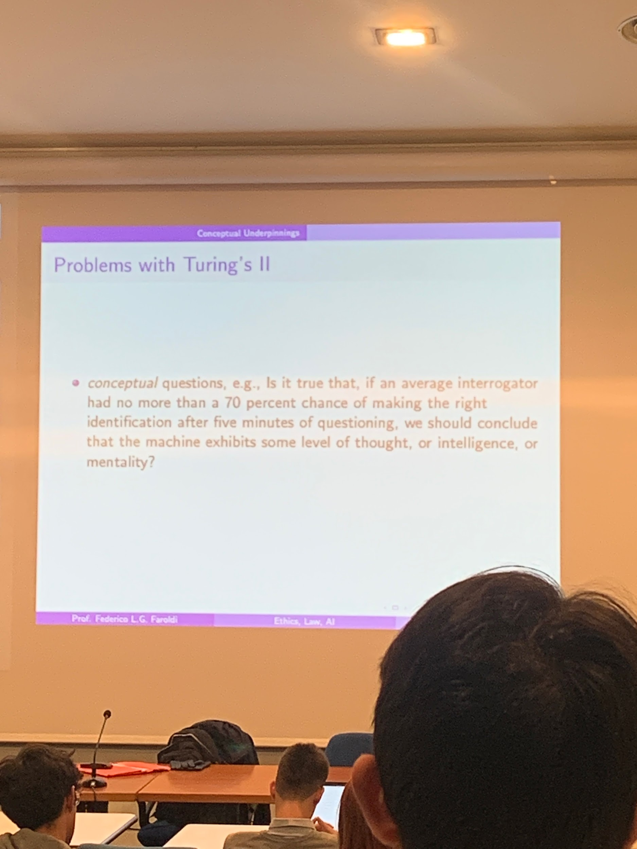

Limits of Turing test

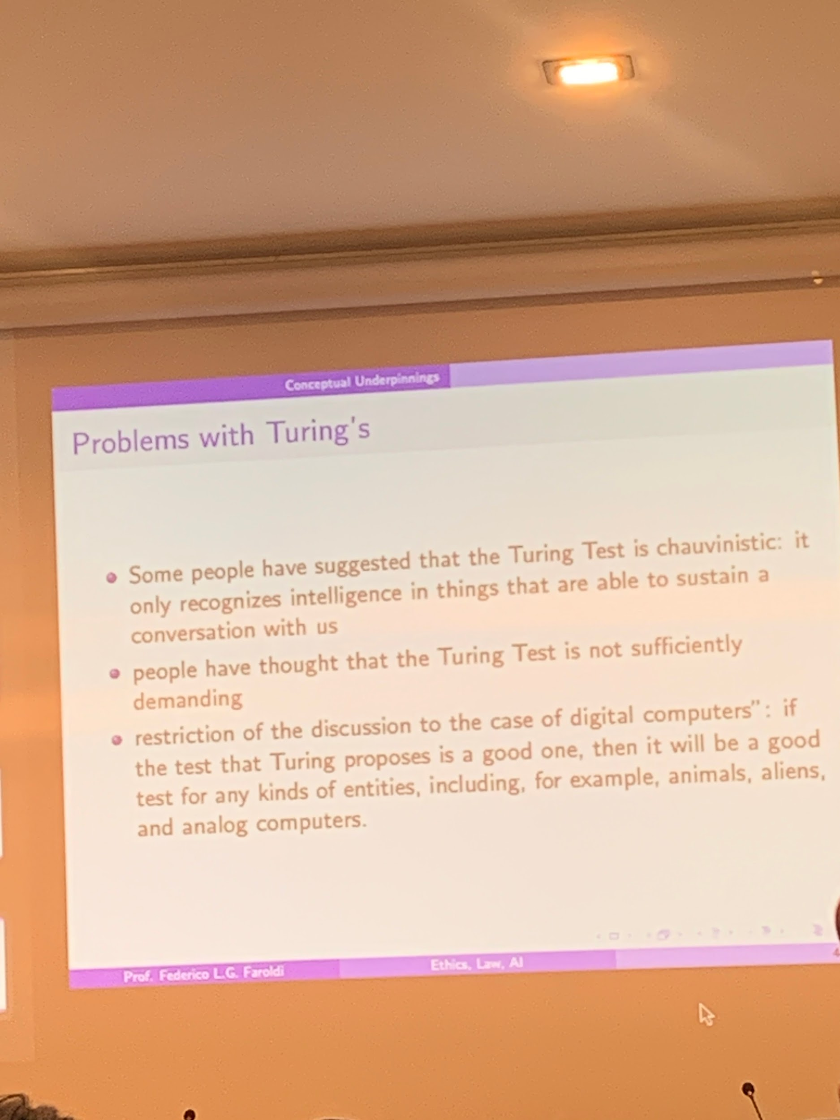

Limits of Turing test

* **chauvinistic**: take man as the measure of all things. Intelligence definition holds to non-human things by following our standards
* The Turing test is **not sufficiently demanding**. Even if a machine can 100% fool us, that is still not enough to consider the machine as intelligent or capable of thinking.
* If the Turing test were a good test then it should apply to others things that are not necessarily digital computers. Some animals display some level of intelligence, they can learn and use tools, and seem to have goals. So, Turing should be applied to other things considered intelligent. **It applies only to one specific category of objects**. It should be potentially applied (with some adaptations) to other animals.

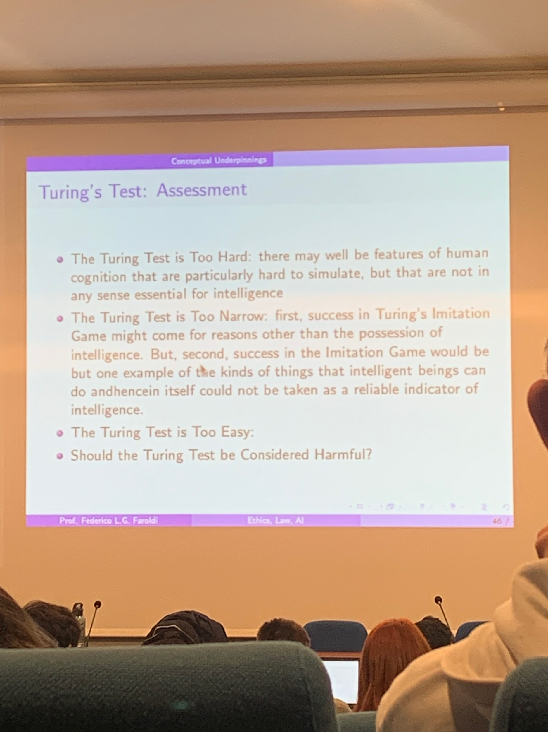

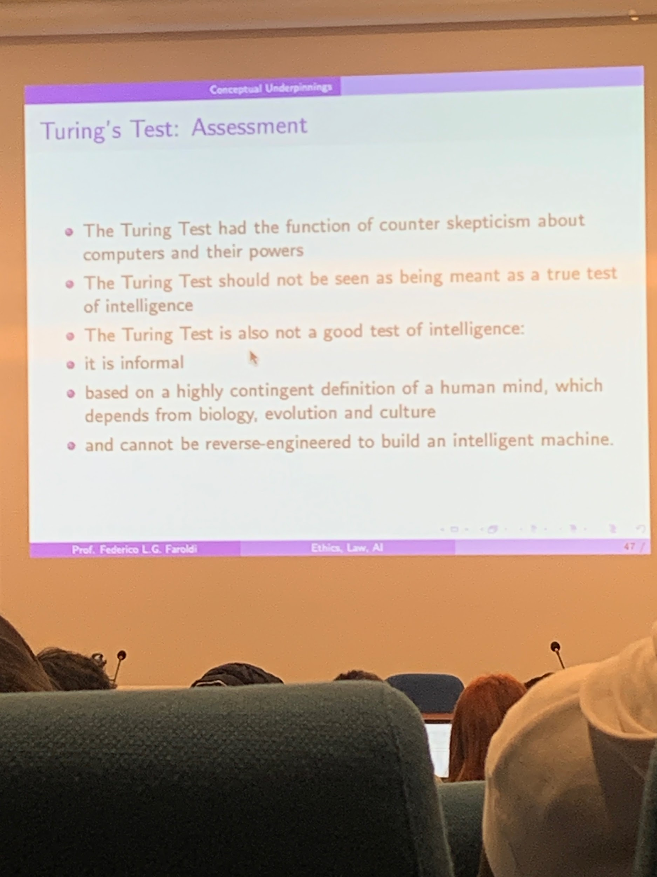

Some aspects of the paper seems that what Turing meant was to counter skepticism about computers

What we can take away from it is that we should not really take the Turing test as a real true test of intelligence (whatever intelligence might mean). **Turing, not a good test of intelligence**, is informal (not objectively quantifiable). And based on a highly contingent definition of the human mind, does not come across a good definition of test. Can not be reverse engineered, to then build an intelligent machine.

**SEARLE’S CHINESE ROOM**

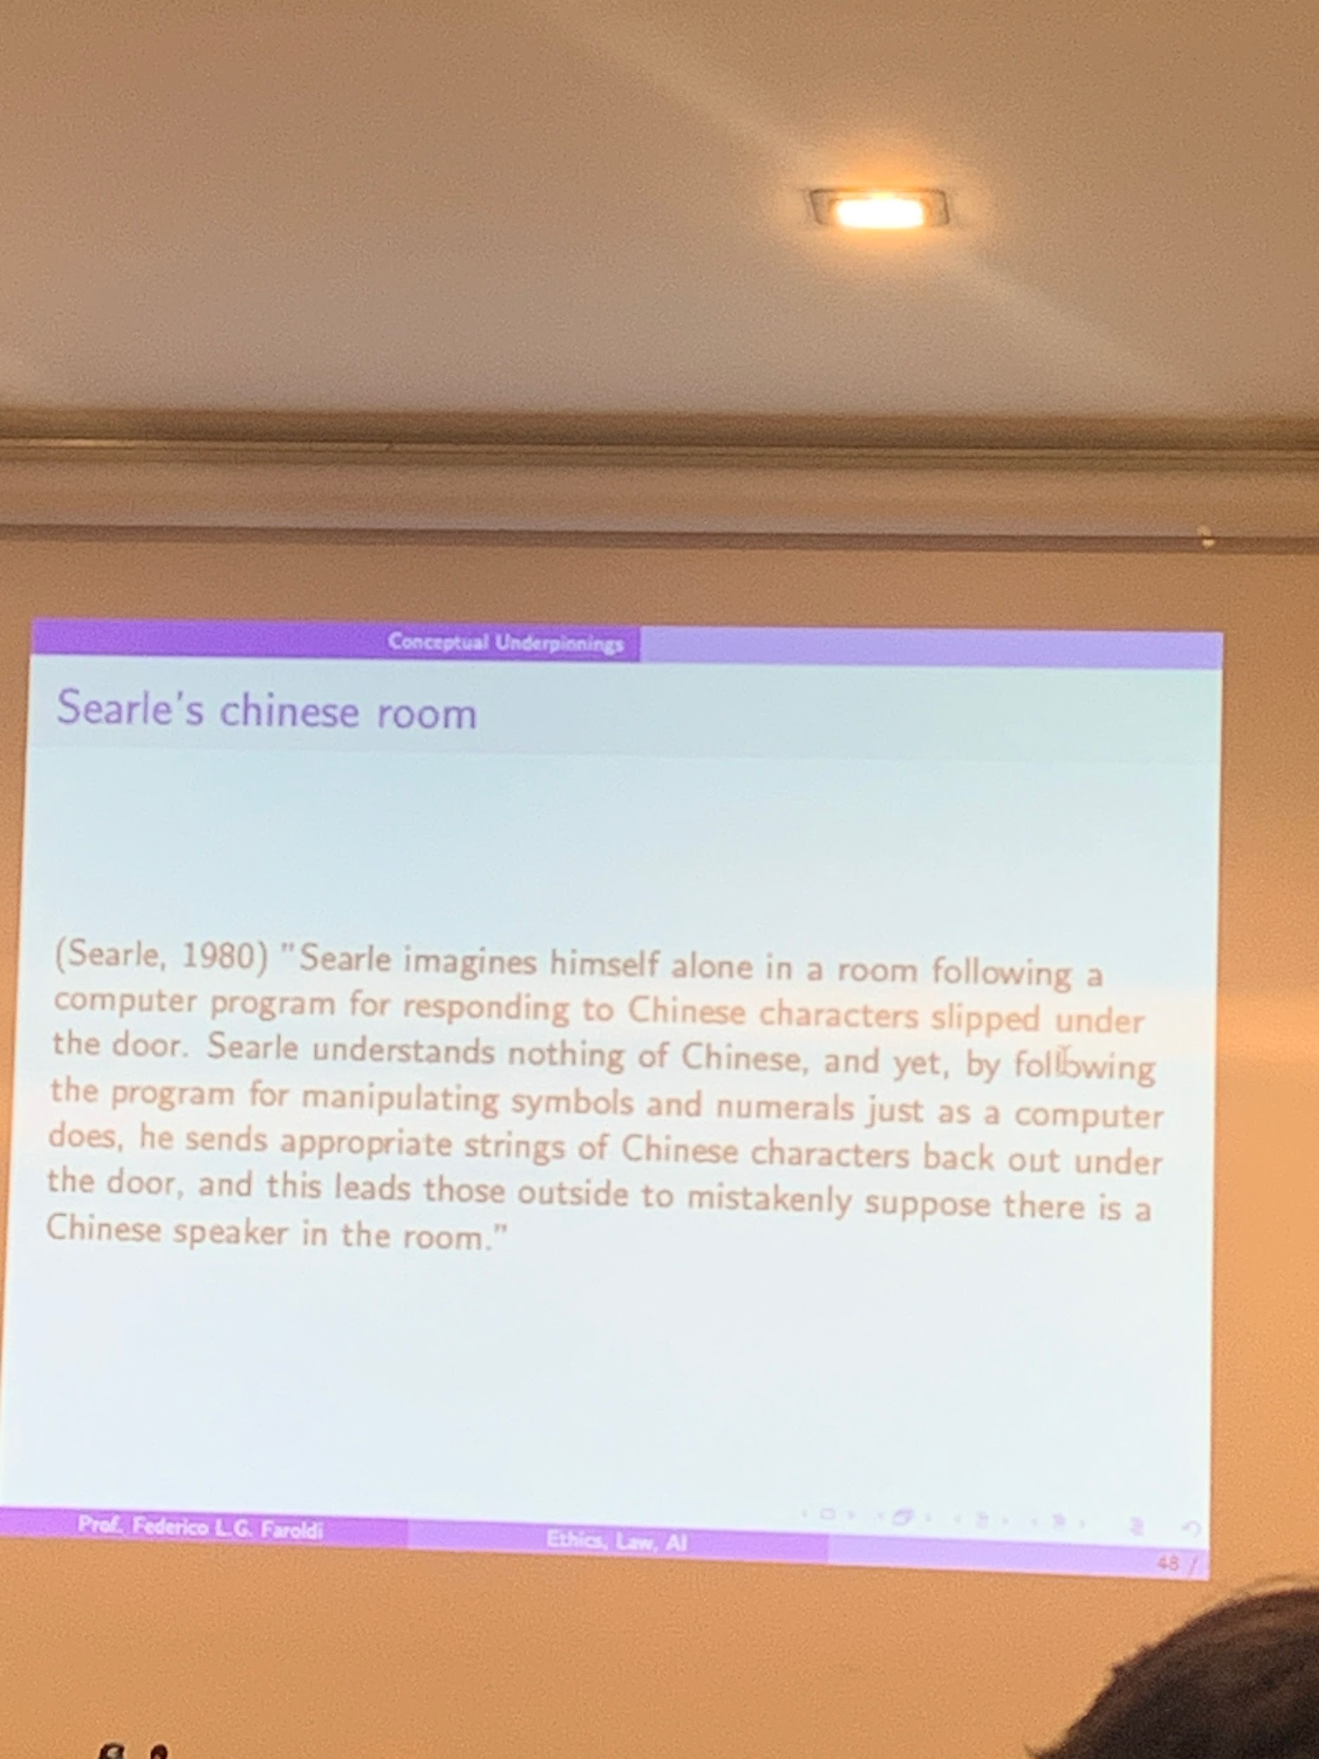

people were excited about Turing ideas, trying to build machines to pass the Turing test. ideas of Searle: let’s assume that we have a machine that imitates perfectly well human behavior, something that is not so easy to understand a story. Searle what to show that this is yet not enough.

Introduce terminology that stay with us those days (weak vs strong AI)

**weak AI**: could imitate humans

**strong AI**: has true intelligence (for Searle: intelligence = conscious, intentionality, understanding).

Narrow vs general AI

**Narrow AI**: something like *alpha 0, GPT3, Dall-E*. Something that executes a task in human/superhuman level

**General AI**: would be an AI that performs at least at human level on a broad level of tasks. [a subset is superintelligence].

Do weak *AI and narrow AI vs General AI and strong AI* combine?

[searle1980 (1).pdf](https://drive.google.com/file/d/1gPpeMCbMceFFpjUmhG6wE0VRS-urpQFF/view?usp=sharing)

what passes the turing test is weak AI

[Some brief notes on Searle, “Minds, Brains, and Programs](https://beisecker.faculty.unlv.edu/Courses/Phi-101/SearleNotes.html)

[The Chinese Room - 60-Second Adventures in Thought (3/6)](https://youtu.be/TryOC83PH1g)

ABSTRACT:

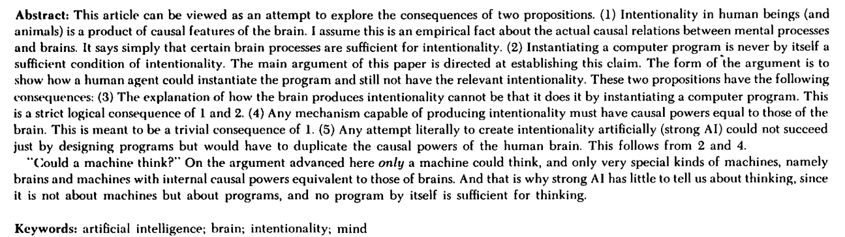

Machines that are able to understand. Not correct to say that is applicable by a machine through a program. Important for distinction between weak and strong AI. states some examples.

Somethings strange in the abstract: intentionality in human beings and animals

product of features in the brain. Certain brain processes are sufficient for intentionality.

**Sufficient condition**: A sufficient condition of B A → B as soon as you have A is the case for B. But this is not necessary

**Necessary**: A necessary condition of B. B → A. If B fail to be the case we can infer that is the case for B

**Necessary and sufficient condition**: B ↔ A

Sufficient condition: *having a dog is a sufficient condition to have a pet*.

Necessary condition: *is necessary to attend the test meeting to pass the exam*

Necessary and sufficient: *being an even natural number is sufficient and necessary to not be odd*.

coils be others features that could get us intentionality (fromd edition of sufficient relation if it is not necessary).

claim 4, *Any mechanism capable of producing intentionality must have causal powers equal to those of the brain. This is meant to be a trivial consequence of 1.* doesn't seem to be a trivial consequence of 1. shows that instantiate a computer program and still have no understanding, not enough to behave in a certain way to pass the turing test. Not enough to have understanding (and so is not a true intelligence).

**SEARLE “*MINDS, BRAINS AND PROGRAMS” -* 1980**

[Searle, Minds, Brains and Programs, 1](https://youtu.be/uOmMs2Uot0g)

Old paper but is a classic.

Overview:

Casual and physical features of the (human) brain produce intentional state (aka you are thinking about something, consciousness of something). *Can a computer think about something? Can they have intentionality directed towards something as we humans do?*

What you read *cat* you find the meaning behind the word, you know the meaning and you have the full-blown intentional state. Our brain produces the intentional state but computers can not do that. **Computer programs inside your computer can not produce intentional states**, they are produced inside the human brain. The computer doesn't have the physical structure.

Humans are a “special biological machine” that can think. Everything that thinks has to have the right kind of causal architecture that a brain does (and a computer does not have). You can not produce intentional state unless you have a causal architecture underneath it.

*How do you show that a computer (program) can not produce an intentional state?* ⟹ this is the thought experiment of Searle aka **the chinese room**. To show this you have an human instantiate (*rappresentare*, to be the computer) a computer and not have an intentional state.

If someone is instantiating (functioning like) a computer and the output is indistinguishable from someone who has intentional states.

A mechanism that produces intentional states must have brain-like causal powers. If there is a causal architecture that produces this then it is probably the case that causal architecture that produces intentional states has to be a causal architecture that has brain-like powers.

**NOWADAYS:** Change our mind a lot about animal cognition, *can nonhuman animals have intentional states?* mind architecture similar to the human one.

Searle: machine can think and is not possible to have intentional states only if there is some kind of physical architecture.

AI types:

* Weak AI: AI that can do a very specific thing. Very narrow. Our smartphone has AI inside but it does not mean that it has a mind inside. It can be done very fast and very well. The computer is a useful tool
* Strong AI: it is a mind.

**Thought experiment: chinese room**.

Intentional states can not be produced by a computer (in the specific sense of programming) but certainly intentional states can be produced by physical mechanism. Our brain can produce the intentional states.

*How can we exclude computers from being places where you have these intentional states?* ⟹ **CHINESE ROOM**

Look at the Chinese character that for you is meaningless. You can not state the meaning but can recognise when two are the same. You can correlate them but in a rudimentary way.

Receive Chinese input and you can produce output. You receive an order of Chinese scripts and you have rules (in English) on how to correlate the Chinese symbols. In this way you are able to produce as output a string of chinese symbols. You had a question about a story and you produced the correct answers without having any clue.

The rules ⟹ are programmed by some that speak Chinese (and English). And you are functioning like a computer. You feed the program in, you read and instantiate the program by correlating the symbols and after you do this the programmers get really good at mapping such that the person that reads your output thinks you understand Chinese very well. You become indistinguishable (in terms of your output) from somebody who is fluent in chinese.

You are doing uninterpreted symbol manipulation as computational operations on formally specified elements. You are functioning like a computer (no intentional state) and indistinguishable from the outputs of someone with intestinal state (that speaks chinese)

Symbolic manipulation is just part of what we do, but there is always a distinction between **syntax and semantics**.

* Syntax: like grammar, the rules that you can follow for produce string that look like they have a semantic content
* Semantic:

CU: Capacity of Understanding. *Can machines in principle have CU?* YES, there must be some level of complexity and it has has to be physical ⟹ physical complexity machine.

But if you keep programming and programming you can have complex programs but you are not going to get a ming popping out all of a sudden.

Searle doesn’t understand Chinese by dint of following instructions in a book, we shouldn’t believe that a computer could genuinely understand English (or any other language), merely by virtue of following a computer program.

In addition, Searle also takes the Chinese Room thought experiment to be a counterexample to the Turing Test. Here we have something that can pass the Turing test, yet has no genuine understanding at all.